GUIDE FOR PREVENTIVE CARE PC9 DESIGN CHANGES FROM PC8

Vivek June 10, 2016

**SLIDE 1: STANDARD PAGE TEMPLATE FOR ALL PAGES**

Standard layout. All pages should say “PREVENTIVE CARE - Wireless Routers” with logo (make sure you use best logo resolution .ps file).

Keep first navigation bar always the same for every page. Search and Map is now Filter.

Dashboard is new, Histogram is Resource Histogram, and Repair is Auto Fix and Manual Fix.

User Manage needs to go inside User icon button on 1st navigation bar.

**SLIDE 2: MAP PAGE**

User clicks on MAP icon after entering Filter content. Second level filtering on left column, and we can enter multiple filters.

We need to improve MAP. John suggested ReactMap. Please make sure we can show density of devices with value and not just pins. Shared with John some examples.

**SLIDE 3: MAP PAGE**

Show one-line per device listing of devices that match the filter on left column.

**SLIDE 4: SEARCH LISTING PAGE**

Listing of devices shows after User clicks on Search icon at the right of Filter. List Thumbnail (default) and one-line per device formats (user selectable) as in my example.

**SLIDE 5: DASHBOARD**

Make this the default Home page when we get a lot of data we can fill in. Otherwise, make Search Listing (Slide 4) the default home page.

Dashboard shows info for what has been filtered from Search or Map pages.

Second line navigation bar appears to show the filters, # of devices found, and Device Diagnostics button. Device Diagnostics button is the new Remote Diagnostics and the button is active ONLY when one (1) device is Filtered. More is explained in SLIDE 6.

So, the Dashboard shows the summary status of multiple devices or just 1 device.

Upper half of the Dashboard shows Max Speeds (Internet & WiFi/Internet) on the upper left and WiFi Interferences/Capacity on the upper right. The lower half of the Dashboard shows 4 quadrants: Attached Devices, Video Streaming Quality, Video/Audio Conferencing Quality, Online Gaming Quality.

1. Internet Speeds and WiFi vs Internet Speeds  
   Dual guage or quad guage that compares for Current & History (drop-down selection for time period):
   1. Internet DL Speeds vs Used Internet DL Speeds Used for Current and History (drop-down selection for time period)
   2. Internet UL Speeds vs Used Internet UL Speeds Used for Current   
      and History (drop-down selection for time period)

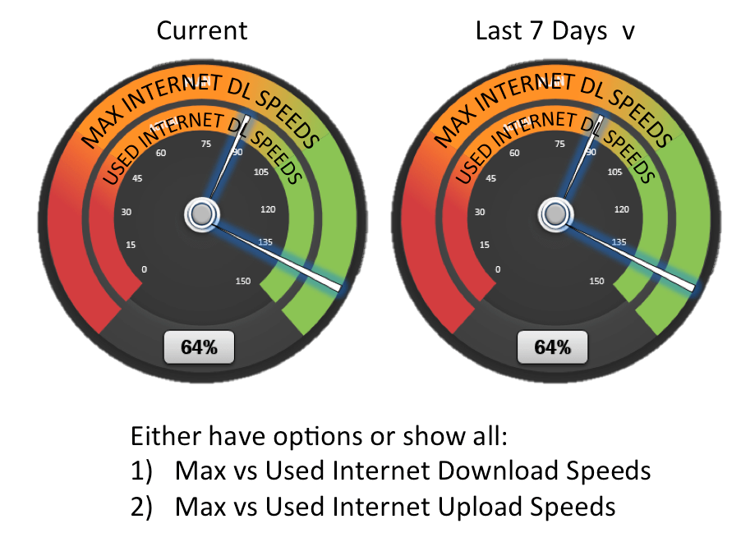

* 1. Used Internet DL Speeds vs Used WiFi TX Speeds
  2. Used Internet UL Speeds vs Used WiFi RX Speeds

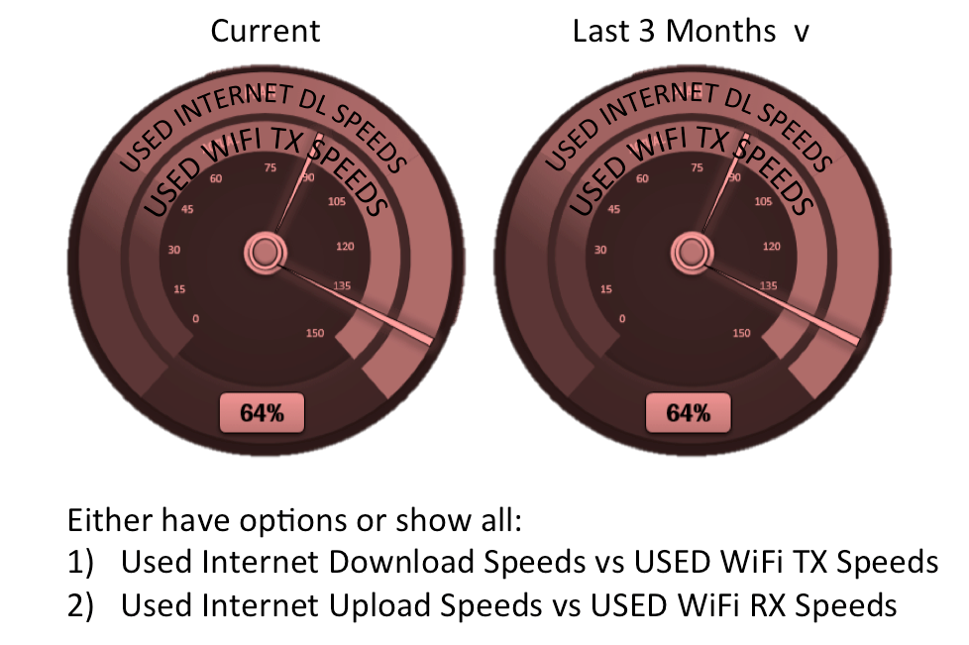

* 1. We show % of total used for (a) and (b).

1. WiFi Interference / Capacity  
   Use what Broadcom has created with WiFi Insight.  
   Let’s investigate what info best makes sense from a top-level Dashboard view.  
     
   **\***REFER TO BROADCOM WIFI INSIGHT SCREEN SHOTS FROM AARON.
2. Attached Devices, show the Average # of Attached Devices per home (listing each type of device as in the example) in
   1. Bar chart of # of devices for each type, and
   2. Pie Chart of %age mix (distribution)

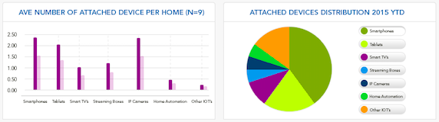

1. Video Streaming Quality, show for buttons Internet, WiFi LAN, and Both (end-to-end Internet to WiFi client down – when we have Omny IQ running in client device like a Roku box). Show Current and History for HD, SD, or LD (lower resolution) Video Streaming Capacity available by hour of day. Use video streaming quality testing software from Internet to Router and from Router to WiFi Client, and from WiFi Client to Internet. If we can only test Internet to Router initially, that will be fine.

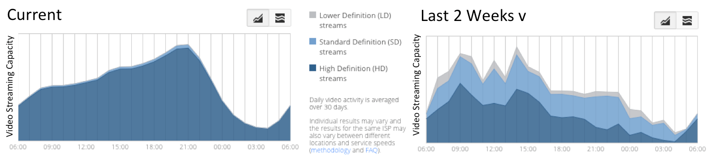

1. Video / Audio Conferencing Quality, show for the time of day, the Wireless Router/Home Network fit for HD, SD or LD video conferencing, given the Internet and WiFi available bandwidth and the processing capacity left on the Router (CPU/Mem). This graph shows at what hours do we have high, medium or low video conferencing capacity. High can mean multiple HD video conferences can stream through. Low means the home network does not have enough capacity to run video conferences. We shall show the relative comparisons of current vs historical trends.

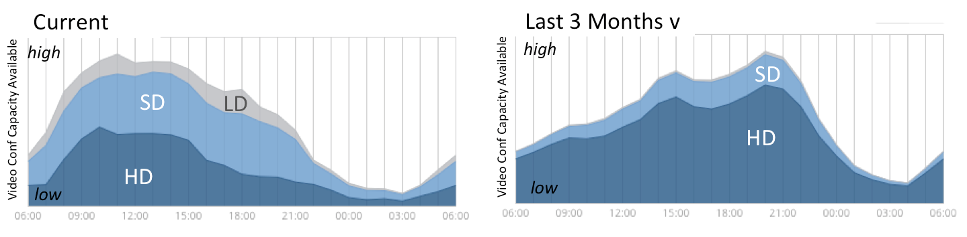

1. Online Gaming Network Quality, show in what hours in this home is the home network available for Online Gaming, by computing the factors of network latency, delay variation, and loss rate across Internet, Router (CPU/Mem), and WiFi. Again, we show current and history comparisons.

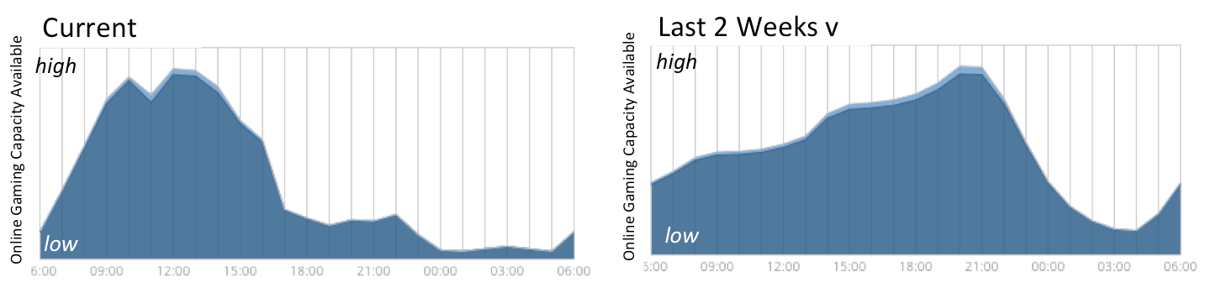

**SLIDE 6: DEVICE DIAGNOSTICS**

Second line navigation bar appears to show the filters, # of devices found, and Device Diagnostics button. Device Diagnostics button is the new Remote Diagnostics. The button is ONLY active when 1 device is selected, as in entering the Serial # of a device or selecting one device from a Search listing. The contents of Device Diagnostics appears after clicking the active button. The contents shows up as an “expansion” of the Dashboard page. Device Diagnostics is only enabled and the button is active ONLY when one (1) device is selected.

The contents of Device Diagnostics are similar to Remote Diagnostics. Follow the layout in Slide 6. The Changes from Remote Diagnostics are:

1. Replace Recommendations with a column to enter notes from the User, if possible.
2. Add WiFi 5GHz under Current Status with 1 week (7 day) average.
3. Add CPU/Memory tab and insert CPU and Memory and firmware version graphics from Rmote Diag into that tab.
4. Add “Scan WiFi” under Command Center.
5. Freeze Window Pane so main Dashboard appears below the expanded window. So, keep the size of the Device Diagnostics fixed and not covering the whole page.
6. Add Navigation Tab with Device Diagnostics highlighted, then the tabs for Reboot Snapshots, Top 10, Log Analyzer, etc.

**SLIDE 7: DEVICE DIAGNOSTICS / Reboot Snapshots**

Shows how we integrate the rest of Remote Diagnostics into this Device Diagnostics page.

**SLIDES 8 & 9: HISTOGRAM**

Insert Resource Histogram into this section. Show Device Diagnostics button below the upper half Histogram window. Additional Filters can appear in second navigation bar. Freeze Window Pane size for upper half of Histogram page and allow upper right listing of products to scroll up/down within that fixed size.

See how Device Diagnostics page appears (WITHOUT the main Dashboard contents showing). Device Diagnostics section can scroll up/down BUT cannot cover the upper half of the Histogram page (frozen window pane).

When Device Diagnostics button is clicked, the Dashboard page with “expanded” Device Diagnostics appears.

**SLIDES 10 & 11: REPAIR**

Create a AUTO / MANUAL button selections to show the contents of Auto Fix and Manual Fix.

Create another button selection for Reboots and other reserved rule-based repairs we do in the future.

Change wording of Auto Fix to what I have proposed in red ink.